

_________%

48

**Year 7 HASS- Geography**

***Task 1: In Class Test (7%)***

***(Introduction to Geography and Water in the World)***

Name: ________________________ Teacher: ___________________

**Time: 5 minutes reading time and 50 minutes working time.**

**Section One: Multiple Choice**

*Read each question carefully, and circle only one option from A-D with a pencil as your response.*

**(10 marks)**

1. **What does the ‘I’ in PERTIC stand for?**
2. International
3. Interconnection
4. Infiltration
5. Intercontinental
6. **Which of the following is not a renewable resource?**
7. Solar
8. Wind
9. Coal
10. Hydroelectricity
11. **Approximately what percentage of the world’s water is fresh?**
12. 50%
13. 2.5%
14. 90%
15. 1%
16. **When water escapes directly from plants, it is called:**
17. Condensation
18. Infiltration
19. Transpiration
20. Precipitation

1. **Why are renewable resources important for us to manage and use?**
2. Because they are just generally better than using non-renewable resources
3. Non-renewable resources are actually better because they include coal, diamonds and uranium
4. Because water is a renewable resource, and Australia is surrounded by water
5. Because they will replenish themselves naturally over time if we do not use them too quickly
6. **During evaporation water goes from a _________________ to a ___________________.**
7. Solid, gas
8. Liquid, gas
9. Liquid, solid
10. Liquid, plasma
11. **Which of the following water scarcity management strategies is related to turning salt water into fresh water?**
12. Recycling
13. Harvesting stormwater
14. Desalination
15. Droughts
16. **When we examine the planet’s ability to provide resources to satisfy current needs whilst satisfying the needs of future generations, we are looking at:**
17. Sustainability
18. Environment
19. Interconnection
20. Change
21. **Which of the following does NOT belong to economical water scarcity?**
22. Not enough money invested in water infrastructure
23. Limited rainfall causing a drought
24. Water pollution caused by tourism
25. When governments do not distribute water equally among people in a country
26. **Which is NOT one of the seven geographical concepts?**
27. Place
28. Transformation
29. Change
30. Interconnection

__________________________________________________________________________________

**Section Two: Short Responses**

1. **Categorise** the list of resources below.  **(4 marks)**

|  |  |  |  |
| --- | --- | --- | --- |
| *Coal* | *Tides* | *Fish* | *Oil* |
| *Solar* | *Plants and Animals* | *Natural Gas* | *Wind* |

|  |  |  |
| --- | --- | --- |
| Renewable | Non-Renewable | Continuous |
| Plants & Animals  Fish | Coal  Natural Gas  Oil | Wind  Tides  Solar |

1. **Explain** the difference between renewable and non-renewable resources.

Provide at least one example of each to support your response.

*\*Use words and phrases such as ‘on the other hand’ ‘however’ ‘for example’\** **(5 marks)**

* 1 mark for correctly outlining what a renewable resource is
* 1 mark for outlining what a non-renewable resource is
* 1 for any accurate example of renewable
* 1 mark for any accurate example of non-renewable
* 1 mark for using words/phrases to differentiate between the two ie/ However, where as, on the other hand.

1. Use the word bank below to assist you to **label** the Water Cycle diagram.  **(5 marks)**

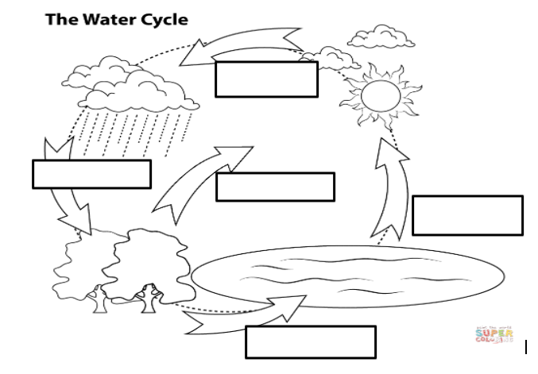

|  |  |  |
| --- | --- | --- |
| **WORD BANK** | Evaporation | Precipitation |
| Condensation | Run-off | Transpiration |

1. **State** which stage of the water cycle is missing from the diagram. **(1 mark)**

Infiltration

1. Choose one stage of the water cycle and **define** it below. **(2 marks)**

1 mark for basic definition

2 marks for comprehensive definition of the stage

_____________________________________________________________________________________________________________________________________________________________________________________________________________________________________________

1. **Define** the term water scarcity. You will need to include an example in your response. **(3 marks)**

* 1 mark for accurate definition
* 1 mark for correctly structuring definition ie. Water scarcity is defined as….., and for example…
* 1 mark for accurate example

1. **Outline** difference between physical and economic water scarcity **(5 marks)**

* 1 mark for correctly outlining physical scarcity
* 1 mark for providing a correct example of physical water scarcity
* 1 mark for correctly outlining economical scarcity
* 1 mark for providing a correct example of economic water scarcity
* 1 mark for using word/phrases to differentiate ie. However, where as, on the other hand.

**Section Three: Geographical Skills – Climate Graph**

1. Complete the **climate graph** for Wagin on the grid below, using the temperature and precipitation data provided in the table. Remember your labels! **(10 marks)**

|  |  |  |  |  |  |  |  |  |  |  |  |  |  |
| --- | --- | --- | --- | --- | --- | --- | --- | --- | --- | --- | --- | --- | --- |
|  | **Jan** | **Feb** | **Mar** | **Apr** | **May** | **Jun** | **Jul** | **Aug** | **Sept** | **Oct** | **Nov** | **Dec** |  |
| **Average Temperature (°C))** | 31 | 30 | 28 | 23 | 19 | 16 | 15 | 16 | 18 | 22 | 26 | 29 |  |
| **Precipitation (mm)** | 13 | 17 | 21 | 29 | 54 | 71 | 70 | 57 | 41 | 29 | 18 | 13 |  |

**Source:** Bureau of Meteorology, 2022

1 mark for each of the following:

* labelling temperature (with degrees Celsius)
* labelling precipitation (with mm)
* labelling months
* correct scale for precipitation
* correct scale for temperature
* title
* correct graphing of temperature as line graph
* correct graphing of precipitation as bar graph
* Key
* Using a ruler to ensure accuracy and neatness etc.

Use the climate graph you created to answer the following questions:

1. **Identify** the warmest month(s) of the year in Wagin. (1 mark)

January

1. **Identify** the month that Wagin receives the highest rainfall. (1 mark)

June

1. **True or False:** June has the coldest average temperature each year. (1 mark)

False

**END OF TEST**